FREETARGET
Application Note: Using Witness Paper - II

SUMMARY

freETarget has the facility to add witness paper drive to the basic target. Witness paper ensures that there is always a complete target to put holes into and get a reliable shot location. Using witness paper requires four parts:
- Witness Paper Holder and Guide
- Paper Feed
- Paper Feed Switches
- Software Configuration
Each of these topics are discussed separately

This document discusses witness paper drive construction using both DC and Stepper Motor installation. The construction of the drive is described using the DC motor, and the differences in configuration and wiring is detailed in Appendix A

WITNESS PAPER and GUIDE
Witness paper comes in two widths; 90mm and 165mm. The 90mm width is typically used for rifle shooting, while the 165 is for pistol events. The choice is up to the user, but 90mm is more than sufficient to fill in the black portion of a pistol target.
An example of a paper holder is shown in Figure 1. The witness paper holder is wide enough to fit a 92mm paper roll. This provides a standard 90mm roll with 1mm of clearance on each side. In this example, the witness paper rolls under a round (5mm) bar that lines the paper up with the target. Because of this bar, the witness paper is on a free rolling mount that lets the roll adjust its position as the paper is used.
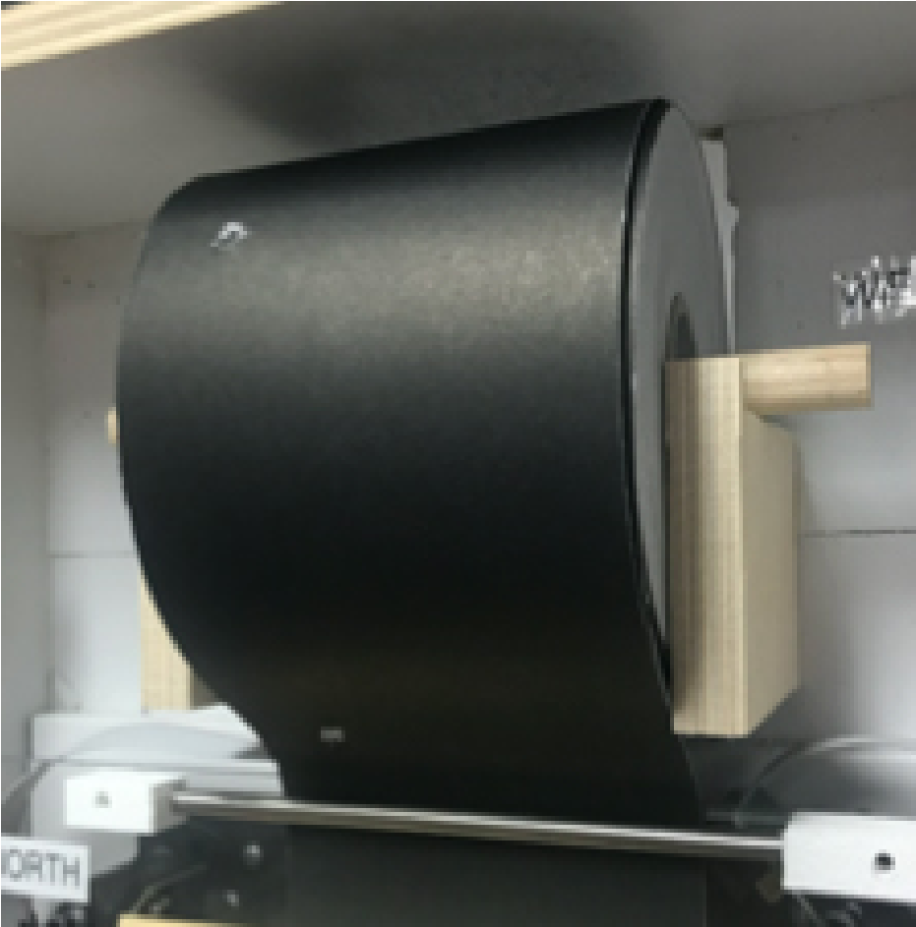
Figure 1: Witness Paper Holder

PAPER DRIVE
The paper drive is made from several components.
- Frame o Base o Left Mount o Right Mount
- Motor
- Coupling
- Drive Shaft
- Pinch Rollers
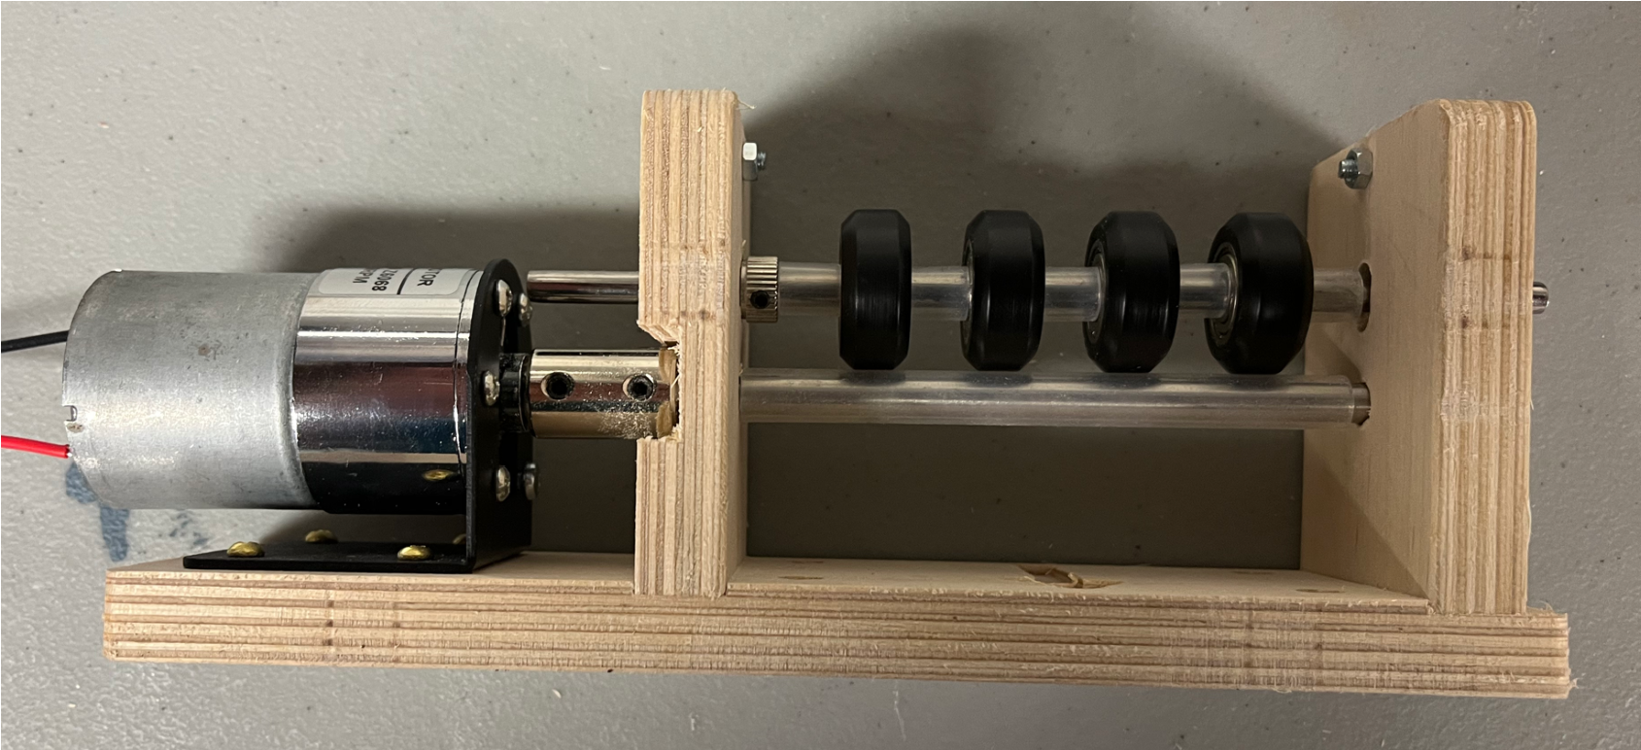

Paper Drive Assembly

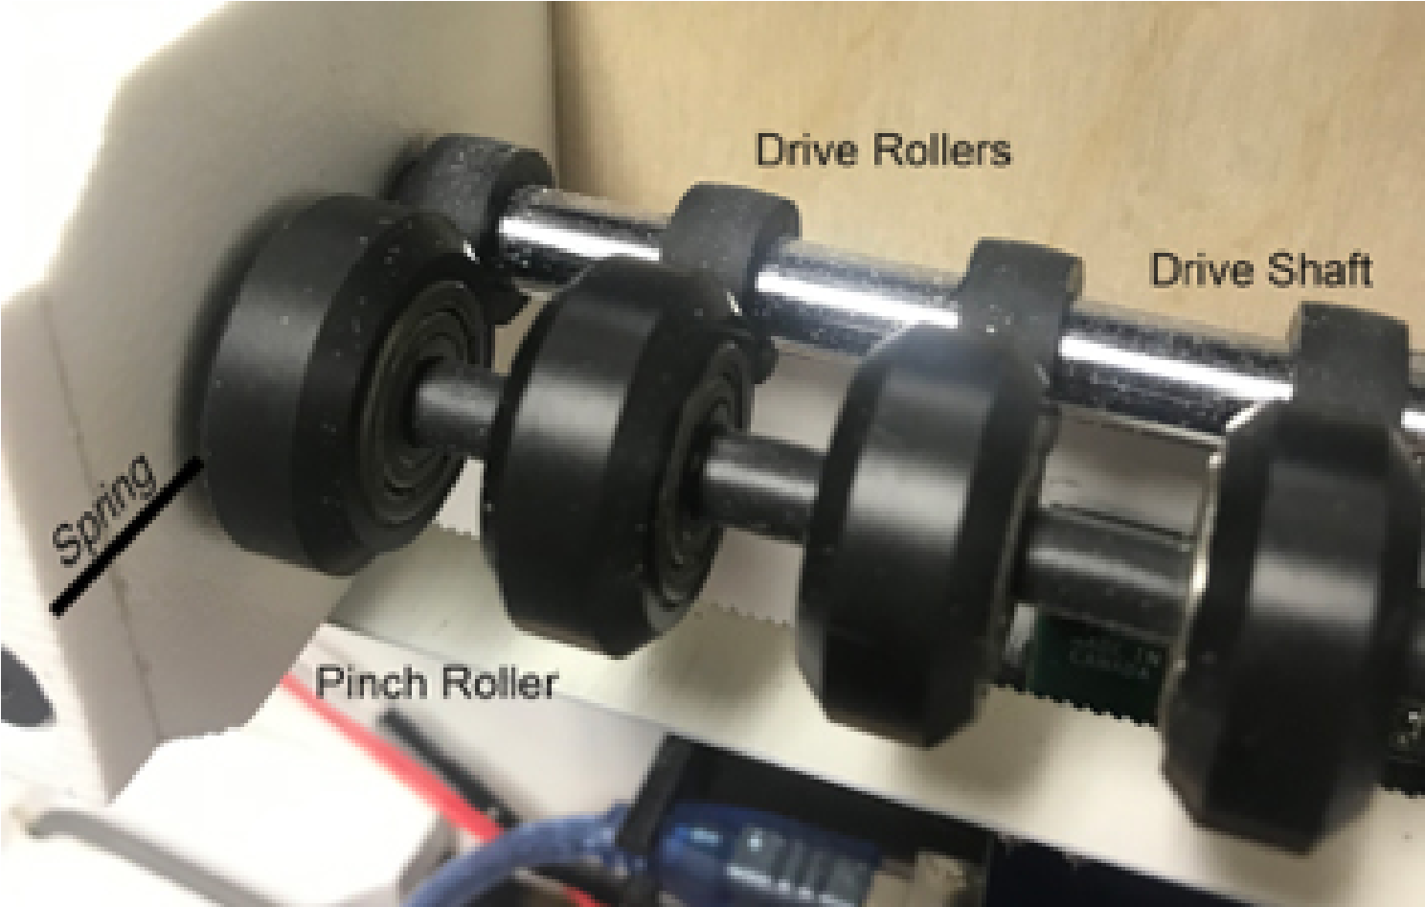

Drive Rollers

Figure 3: Motor Coupling Figure 4: Pinch Roller Bearings

Construction
In this example, the base is made from 1/4” plywood, and the pinch roller bearings from PVC plastic.

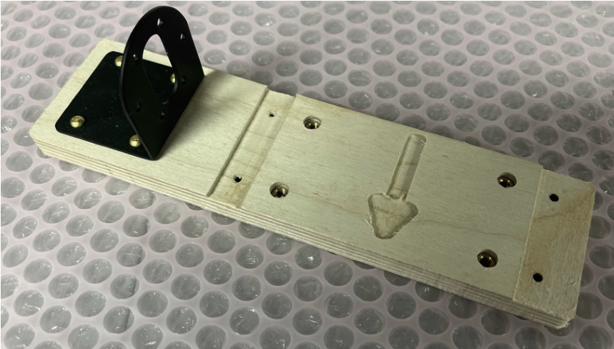
Install the motor mount using four screws

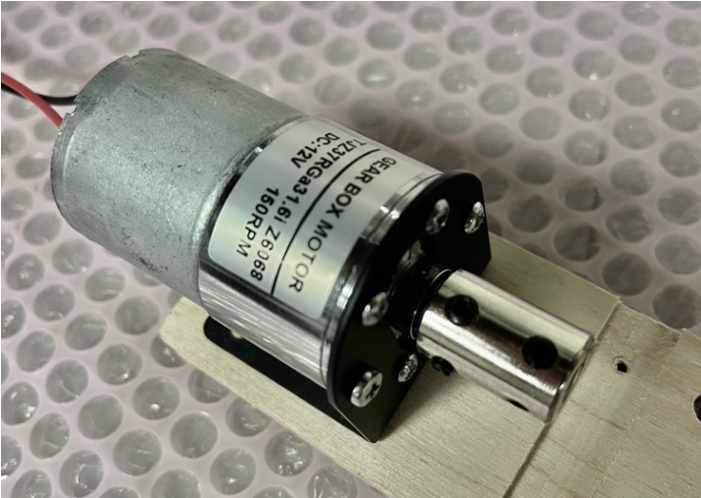
Install the motor using the six mounting screws. Attach the 6mm coupling making sure to line up the flat to the set screw in the coupling. Do not tighten the set screws just yet.

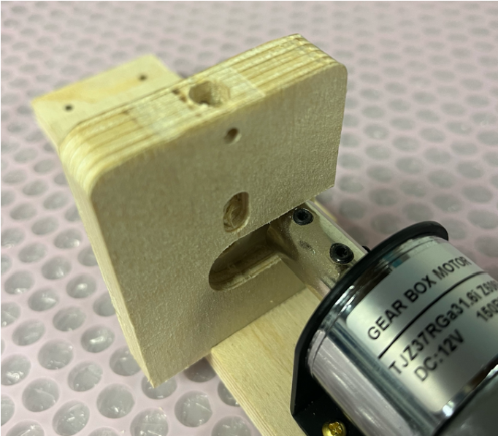
Slide the left motor mount onto the base plate. It fits very snugly into the groove. This is done to keep everything aligned. You may need to tap into place with a hammer

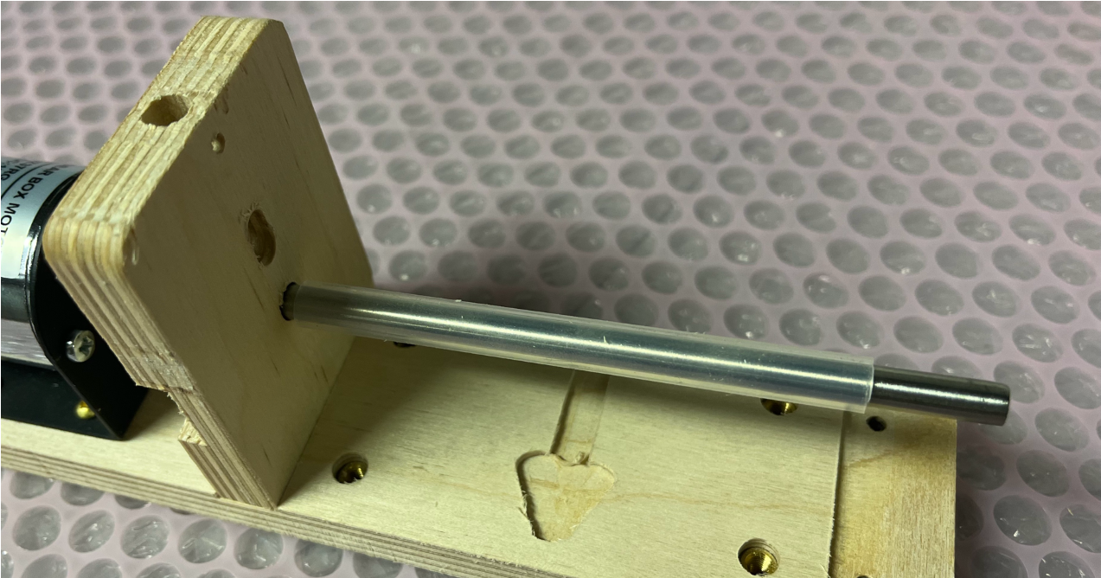
Insert the drive shaft into the coupling. You may need to adjust the rubber sleeve

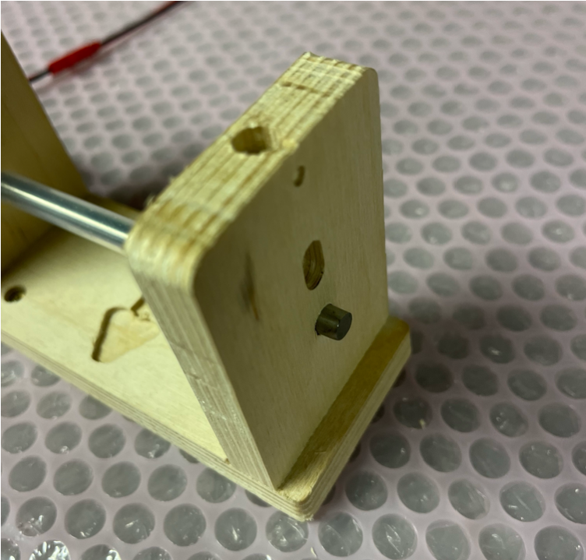
Attach the right mount

Attach the mounting screws on both the right and left mounts.

Tighten the set screws on the motor and drive shaft

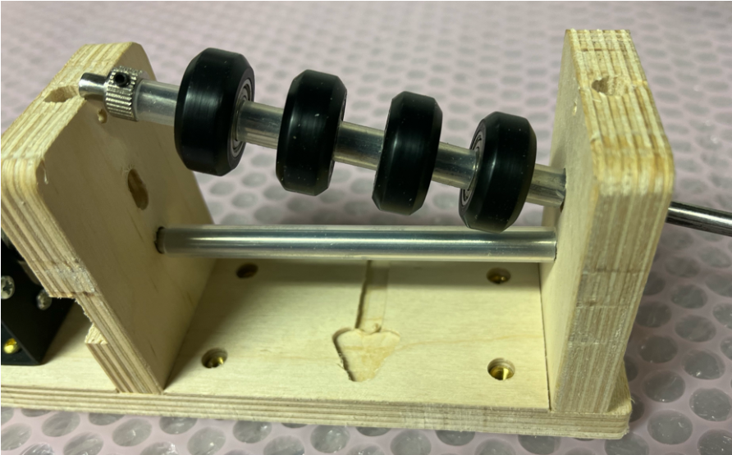
Assemble the pinch rollers
Spacer + Roller …
Spacer + Locking Collar

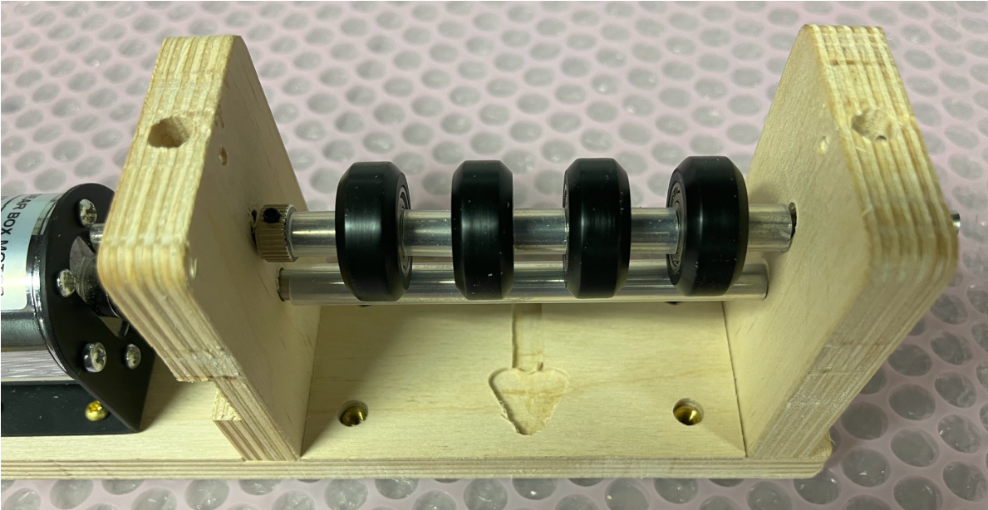
Slide the pinch rollers in place

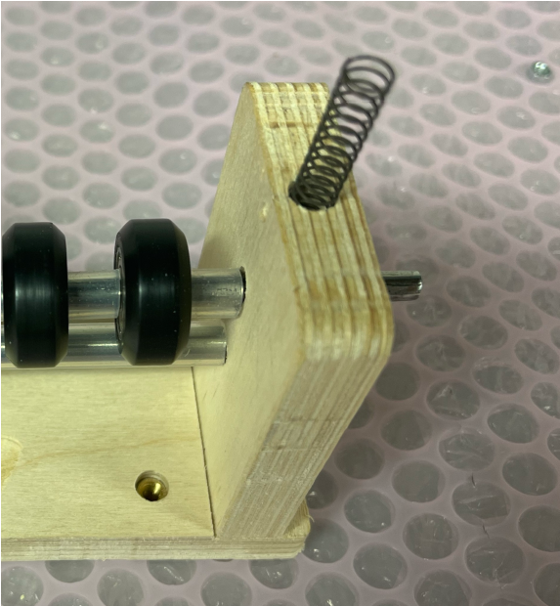
Put the compression springs into both holes.

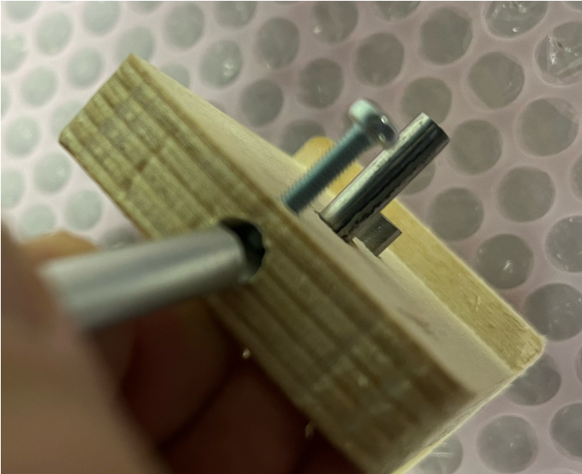
Use a screwdriver or small knife to push the spring in place.

Hold in place with the 3mm retaining screw

Testing
Cut a small length of witness paper and insert it into the drive. The slotted hole for the pinch rollers should be long enough that you can move the pinch roller away and slide in the paper. When the pinch rollers are in contact with the drive rollers the witness paper should not be able to be moved.
Apply power to the motor, does the witness paper move easily? You may find that the drive shaft binds in the mounting plates. If this happens, loosen the bolts holding the plates to the mount by ½ turn.

Wiring
A control to drive a witness paper roller is provided by the Motor Drive Pin. This pin provides a ground connection through a MOSFET transistor.
The user has the option of turning on a DC motor for a period of time, or issuing pulses to a stepper motor controller. The number of pulses and the pulse duration is available from the setup page on the PC program. The duration of the motor control will be installation dependent and found by trial-and-error

A typical connection for a DC motor is shown in Figure 2.

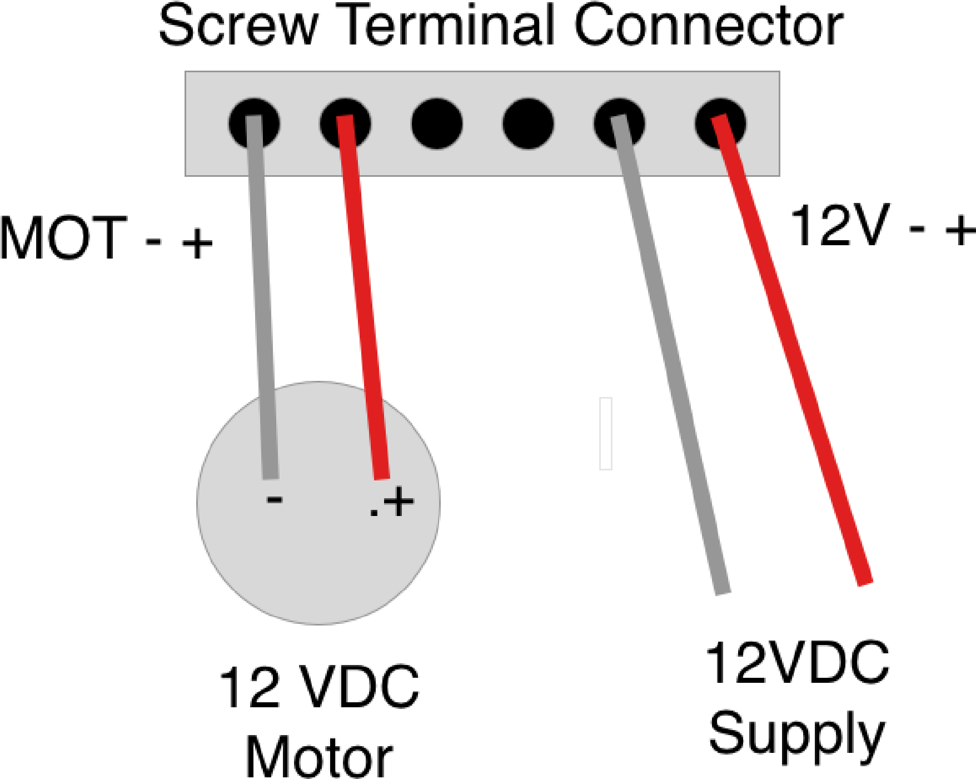

Figure 2: DC Motor Connection Version 5 Hardware

IMPORTANT – Feed Direction
The feed direction is determined by the motor polarity and the assembly of the parts. If the paper feed is backwards to the target, reverse the positive and negative motor leads.

Note: Version 5 hardware includes the switches on the main board.

BILL OF MATERIALS
Most of the materials on this list were obtained from Amazon simply for convenience. Note that Amazon frequently delivers parts in multiple quantities.

Part | Description
Base | 1/2” Plywood or similar
Left Roller Bracket | 1/2” Plywood or similar
Right Roller Bracket | 1/2” Plywood or similar
Fasteners | Various screws to fit
Compression Spring 0.25 dia x 1.75” long | McMaster Carr https://www.mcmaster.com/catalog/128/1415
Part | From Amazon.com
12VDC Motor, 110 RPM (150 RPM may be used) | https://www.amazon.com/gp/product/B08D3SSG55/ref=ppx_yo_dt_b_asin_title_o09_s00?ie=UTF8&psc=1
Motor Mount | https://www.amazon.com/gp/product/B089W6DCGV/ref=ppx_yo_dt_b_asin_title_o09_s00?ie=UTF8&psc=1
6mm Drive Shaft (cut to 125 mm length) | https://www.amazon.com/gp/product/B082ZP23T5/ref=ppx_yo_dt_b_asin_title_o07_s00?ie=UTF8&psc=1
6mm Rubber Tubing for drive (cut to 85mm length) | https://www.amazon.com/gp/product/B07PNR5NJ5/ref=ppx_yo_dt_b_asin_title_o09_s00?ie=UTF8&psc=1
6-6mm coupling | https://www.amazon.com/dp/B07PB9TDCG?psc=1&ref=ppx_yo2ov_dt_b_product_details
5mm Pinch Roller Shaft | https://www.amazon.com/gp/product/B082ZNS27M/ref=ppx_yo_dt_b_asin_title_o09_s00?ie=UTF8&th=1
Pinch Roller | https://www.amazon.com/dp/B07KPWJ3ZC?psc=1&ref=ppx_yo2ov_dt_b_product_details
Locking Collar | https://www.amazon.com/dp/B08BZ5XS2L?psc=1&ref=ppx_yo2ov_dt_b_product_details
Multifunction Switches, Push Button Normally Open | https://www.amazon.com/Twidec-Colors-Momentary-Pre-soldered-PBS-110-  X6C/dp/B07RPS2ZY3/ref=sr_1_5?crid=3GP5B9384M9Z&dchild=1&keywords=no%2Bpush%2Bbutton&qid  =1628540916&sprefix=NO%2Bpush%2B%2Caps%2C181&sr=8-5&th=1

STEPPER MOTOR INSTALLATION

Version 5 hardware (ESP32) and Version 5.2 and higher software supports witness paper drives using a stepper motor in place of the DC motor described above.

Installing the stepper motor requires the following changes to be made to the wiring and software configuration.

- Wiring – Interfacing to the multifunction connector
- Configuration – Setting the software to drive the stepper motor

WIRING

The stepper motor interfaces to the FreeTarget circuit using the J1 multifunction connector as illustrated in Figure 8.

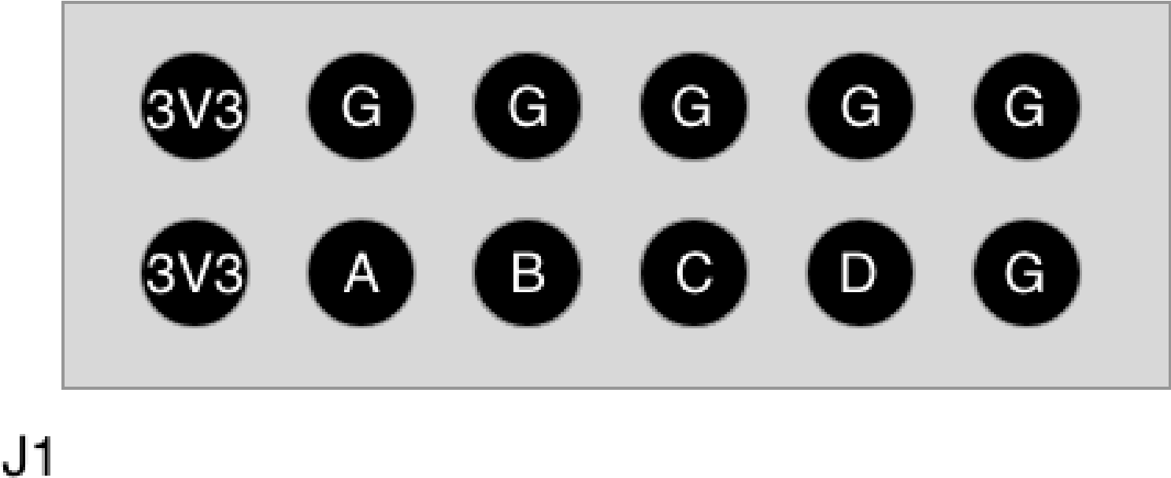

Pin | Signal | Description
1 | 3V3 | 3.3 Volt (50mA) source to drive the stepper motor interface
2 | 3V3 | 3.3 Volt (50mA) source to drive the stepper motor interface
3 | A | Multifunction Switch Input A (Sometimes called input 1)
4 | G | Digital Ground
5 | B | Multifunction Switch Input B (Sometimes called input 2)
6 | G | Digital Ground
7 | C | Multifunction Switch Input or Output C
8 | G | Digital Ground
9 | D | Multifunction Switch Input or Output D
10 | G | Digital Ground
11 | G | Digital Ground
12 | G | Digital Ground
Figure 8: MultiFunction Connector

The connection between the FreeETarget, the stepper motor drive, and the stepper motor is shown in Figure 9.

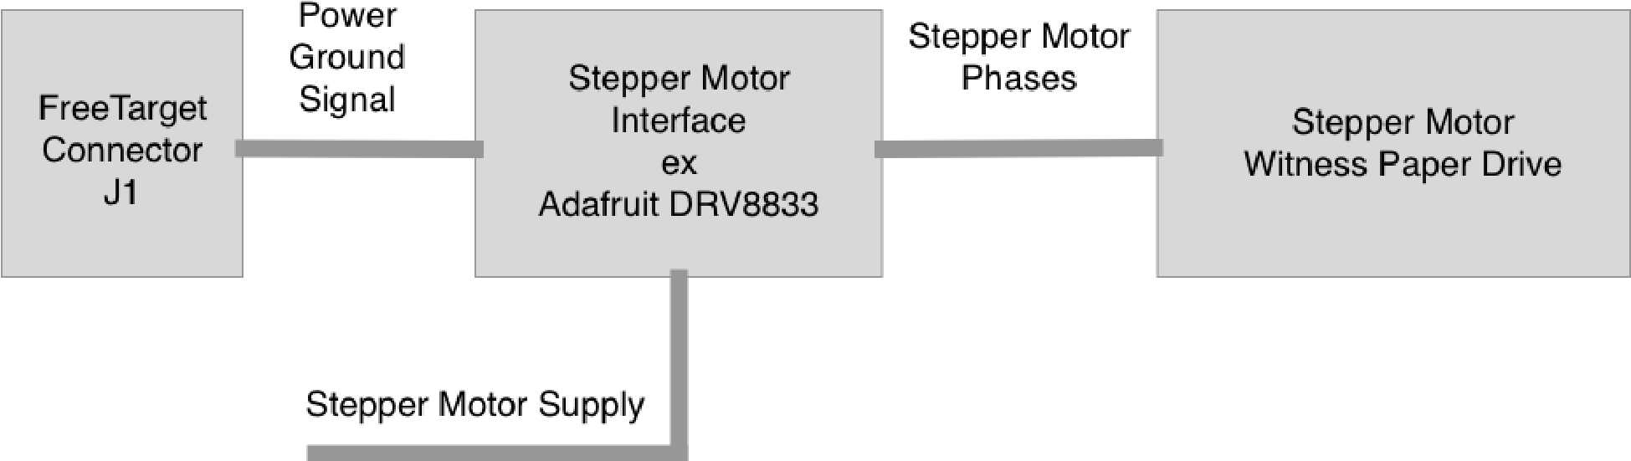
Figure 9: Stepper Motor Drive Installation

Typically the FreeETarget uses 3V3 (Pin 1) Ground (Pin 12) and output C (pin 7).

CONFIGURATION

In order for the stepper motor to operate correctly, the MultiFunction Switches need to be configured to drive the intended output circuit correctly. These are shown in Table 1.

Table 1: Configuration Settings for DC and Stepper Motor Operation

DC Motor Configuration |  |  | Stepper Motor Configuration
{“PAPER_TIME”:X} | Time DC motor runs to advance paper in X ms.  Typically 500 ms |  | {“PAPER_TIME”:0} | 0 indicates DC motor is not used
{“STEP_COUNT”:0} | Stepper motor is not used |  | {“STEP_COUNT”:X} | Number of counts (X) to issue to when advancing paper
{“STEP_TIME”:0} | Stepper motor is mot used |  | {“STEP_TIME”:Y} | Stepper motor clock time (Y) in ms Typically 20ms
 |  |  | {“MFS_HOLD_C”:26} | Use MFS_C as the stepper motor drive

WHERE TO BUY WITNESS PAPER Europe

Kreuger Targets. https://targets.krueger-shops.eu

North America

Chase Turner: krugerpremiumtargets@gmail.com

Orion Systems: Paper Roll for Athena NC Models (orionscoringsystem.com)

Elite Scorer: Electronic target, Electronic targets shooting, Target scoring system (elitescorer.com)

Targets Canada: http://www.targets.ca/products/targets-target-systems-and-accessories

Make Your Own Witness Paper

For true Do-It-Yourself people, there are alternatives to commercially available witness paper

Black wallpaper – Available locally in paint supply stores

Black kraft paper – Example Amazon, https://www.amazon.com/RUSPEPA-Black-Kraft-PaperRoll/dp/B07MNVSB16/ref=sr_1_1_sspa?crid=2SMOTR3V9LWL0&keywords=black+kraft+paper+ roll&qid=1655243454&sprefix=black+Kraft%2Caps%2C80&sr=8-1-
spons&psc=1&spLa=ZW5jcnlwdGVkUXVhbGlmaWVyPUFWOUM4TUFGWVAyNEgmZW5jcnlwdG VkSWQ9QTAzODYxODYzU09YMUg3RFBCUDhSJmVuY3J5cHRlZEFkSWQ9QTAwNTYwODYyQVVO
RURKVDA1RU1UJndpZGdldE5hbWU9c3BfYXRmJmFjdGlvbj1jbGlja1JlZGlyZWN0JmRvTm90TG9n
Q2xpY2s9dHJ1ZQ==

Heat treated cash register paper – Use standard cash register paper and iron it to turn it black

Cut down witness paper – Cut 90mm witness paper in half using a band saw or similar tool Sketch

